Brandon Hough

CPEN 3710

LQF316

Lab Exercise #5

Dumping the contents of the first number



Dumping the contents of the second number

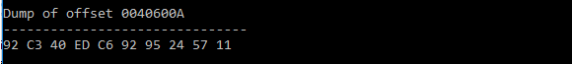

Dumping the contents of the third number



Dumping the contents of the forth number



Dumping the contents of the addition result

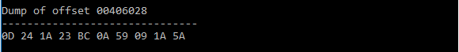

Dumping the contents of the subtraction result



Dumping contents of final registers

